**Power BI Project Report**

**Name: Simran Achra**

**Overview**

The provided data includes customer information and their purchasing behavior. The dataset encompasses various aspects such as demographic details, education level, marital status, income, and purchasing data across different product categories.

**Visualizations and Insights:**

**1. Website Visits vs. Purchases by Spending**

**Trend Observation:**

* Data points cluster towards lower website visits (0-50) and purchases (0-10), indicating low engagement for the majority of customers.
* Increased purchases correlate with more frequent website visits, suggesting higher engagement from higher spenders.

**High Engagement Group:**

* Outliers with high visits and purchases indicate potential loyal customers who require special attention.

**Low Purchase Frequency:**

* Many visitors do not convert into high-value purchases despite varied visit frequencies.

**2. Products Analysis**

**Total Spending by Product Category:**

* Wines: Highest spending category ($681K).
* Meat Products: Second highest spending ($374K).
* Gold Products: Moderate spending ($99K).
* Fish Products: Lesser spending ($84K).
* Sweet Products: Lowest spending ($61K).

**Customer Preferences:**

* Clear preference for wines and meat products.

**Marketing Strategy Implications:**

* Focus marketing efforts on wines and meat products to maximize engagement and sales.
* Targeted marketing needed for lower spending categories like sweet and fish products.

**3. Income vs. Spent Analysis**

**Income Distribution and Spending:**

* Highest spending within $0 to $150K income range. Spending drops beyond $150K.

**Spending Insights:**

* Strong correlation between income and spending up to $150K, beyond which it flattens.

**Marketing Strategy Implications:**

* Target customers within the $0 to $150K income range for marketing efforts.
* Tailored campaigns necessary for high-income customers (above $150K).

**4. Top 5 Customers by Max Spending**

**High-Spending Customers:**

* Customer 5236: Highest spender ($5236).
* Customer 4580: Second highest spender ($4580).
* Customer 1763: Third highest spender ($1763).
* Customer 5453: Fourth highest spender ($5453).
* Customer 4910: Fifth highest spender ($4910).

**Spending Patterns:**

* Top 5 customers exhibit significantly higher spending compared to the general customer base.

**Marketing Strategy Implications:**

* Special attention and personalized marketing for high-spending customers.
* Implement loyalty programs or exclusive offers to engage top spenders.

**5. % of Accepted Campaigns**

**Campaign Acceptance Rate:**

* Majority of customers (98.66%) have not accepted the campaigns, while only 1.34% have.

**Campaign Effectiveness:**

* Low acceptance rate indicates current marketing campaigns may not be resonating with the customer base.

**Marketing Strategy Implications:**

* Review and redesign marketing campaigns to improve engagement and acceptance rates.
* Analyze preferences of customers who accepted the campaigns for more effective future campaigns.

**6. % of Education**

**Education Distribution:**

* Graduation: Largest segment (50.31%).
* Master: Second largest group (21.7%).
* PhD: Represents 16.52%.
* 2nd Cycle: Accounts for 9.06%.
* Basic: Smallest segment (2.41%).

**Educational Insights:**

* Majority of customers have higher education levels (Graduation and above).

Marketing Strategy Implications:

* Craft marketing messages to appeal to an educated audience.
* Use educational content or campaigns that resonate with these segments for better engagement.

**7. Income vs. Marital Status Analysis**

**Income Distribution by Marital Status:**

* Married: Highest income group (over $40M).
* Together: Second highest income group.
* Single: Notable income, though lower than Married and Together.
* Divorced: Lesser income.
* Widow: Lowest income.

**Income Insights:**

* Married and Together statuses contribute the highest to the total income.

**Marketing Strategy Implications:**

* Focus marketing efforts on Married and Together individuals.
* Tailored campaigns for single and divorced individuals to tap into these segments more effectively.

**8. Marital Status Distribution**

**Marital Status Breakdown:**

* Married: Largest segment (38.57%).
* Together: Second largest group (25.89%).
* Single: Represents 21.43%.
* Divorced: Accounts for 10.36%.
* Widow: Smallest segment (0.13%).

**Customer Insights:**

* Majority of customers are either Married or Together.

**Marketing Strategy Implications:**

* Target Married and Together customers with campaigns and promotions.
* Special offers and tailored messaging for Single and Divorced customers to increase their engagement.

**9. Sum of Z_CostContact and Z_Revenue**

**Overall Campaign Cost and Revenue:**

* Z_CostContact: Total cost of 6720.
* Z_Revenue: Total revenue of 25K.

**Cost and Revenue Insights:**

* Revenue significantly exceeds the cost of customer contact, indicating a positive return on investment.

**Marketing Strategy Implications:**

* Expand current marketing efforts due to positive financial results.
* Analyze specific campaigns to identify the most effective ones for resource allocation.

**10. Income vs. Education**

**Income Distribution by Education:**

* Graduation: Highest income group.
* PhD: Second highest income group.
* Master: Moderate income.
* 2nd Cycle: Lesser income.
* Basic: Lowest income.

**Income Insights:**

* Higher education levels are associated with higher incomes.

**Marketing Strategy Implications:**

* Focus marketing campaigns on customers with Graduation and PhD education levels.
* Target efforts for customers with Master and 2nd Cycle education to maximize engagement and sales.

DashBoard

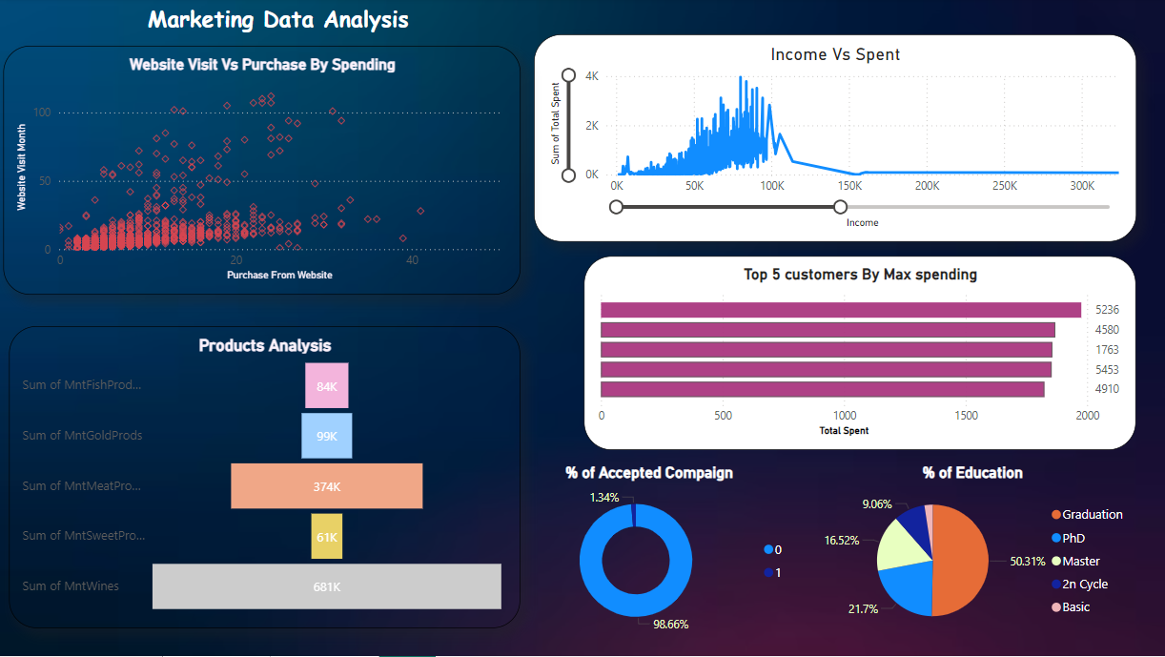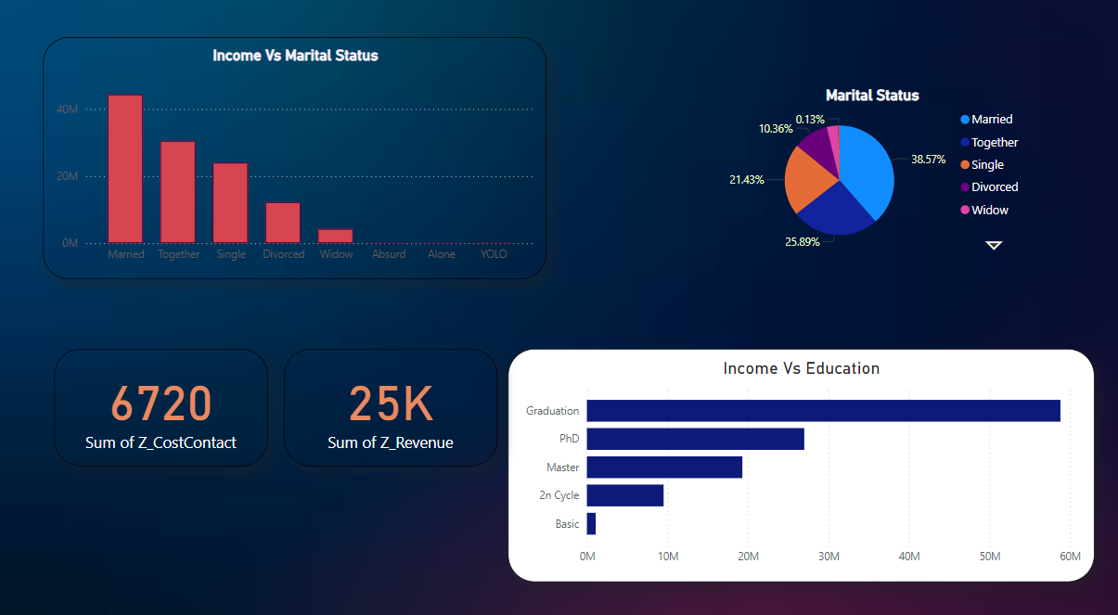

**Summary**

1. Low Engagement: Most customers have low website visits and purchases.
2. Top Products: Wines and meat products are the most popular.
3. Income Range: Highest spending comes from customers earning $0 to $150K.
4. Top Spenders: The top 5 customers spend significantly more than others.
5. Campaign Issues: Current marketing campaigns have low acceptance rates.
6. Educated Customers: Most customers have higher education levels.
7. Marital Status: Married and Together customers have the highest income.

**Recommendations**

1. Target Marketing: Focus on customers with $0-$150K income and higher education levels.
2. Product Promotions: Boost marketing for wines and meat products.
3. Improve Campaigns: Redesign campaigns for better acceptance and personalize strategies for top spenders.